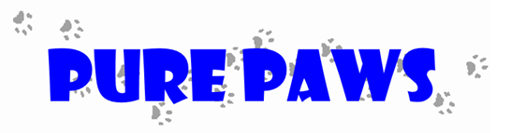

Pure Paws, LLC
The doormat for your dog

Prepared by:
Breanna Ripley
Heath Loeffelbein
Kailey Elfstrum
Andrea Brown

This document contains confidential and proprietary information belonging exclusively to Pure Paws, LLC.
Table of Contents

Executive Summary……………………………………………….………………………...….. 3

The Company…………………………………………………………………………………….6
Company Description……………………………………………………..………………………6
Mission Statement………………………………………………………………………………...6
Objectives and Company Background……………………………………………………………6
Product/Service……………………………………………………………………………....…....7
Industry Description……………………………………………………………………………….9

The Market…………………………………………………………………………………….....9
Market and Target Customer……………………………………………………………………...9
Competition and Competitive Advantage………………………………………………………..12
Marketing Strategy……………………………………………………………………………….14
Competitive Analysis…………………………………………………………………………….15
Research and Development………………………………………………………………………15
Exit Strategies………………………………………………………………………………...….16

The Organization……………………………………………………………………………….16
Legal and Organization Structure………………………………………………………………..16
Key Personnel……………………………………………………………………………………17
Board of Directors………………………………………………………………………………..18
Related Service Providers………………………………………………………………………..18
Location………………………………………………………………………………………….19

The Financials…………………………………………………………………………………..19
Cash Flows……………………………………………………………………………………….22

Appendices……………………………………………………………………………………...23A. Customer Testimonials……………………………………………………………………….23
B. Website Sources………………………………………………………………………………23
C. Financial Extras……………………………………………………………………………….23

EXECUTIVE SUMMARY
Mission Statement:
Pure Paws will do the “dirty work” for you by cleaning, sanitizing, and drying your dog’s paws. We will provide a product to dog owners that is easy to use and eliminates the hassle and annoyance of dirty and unsterilized paws.

Product:
Our team has developed a new and more innovative way for dog owners to not only sanitize, but also moisturize their dog’s paws. This product is designed to provide an easier and more effective way of ridding dog’s paws of germs, mud, and many other unwanted substances, essentially serving as doormat for your dog. Pure Paws is an easily adaptable paw cleaning system. The doormat unfolds into two sections, one side includes a soapy liquid that surrounds and scrubs the paw with rubberized scrubbers. The other side is lined with a super absorbent microfiber fabric that dries the dog’s paws. This is all stored in a compact doormat which seals in the liquid and is durable to walk over when open or closed.

Our product purifies, sanitizes, and moisturizes your dog’s paws by simply having your dog walk over both of the mats. Crosshatching of microfiber rubberized bristles lay over sponge like material which allows for a deep clean of the dog’s paw and foot by simply stepping on our mat as this material surrounds the dog’s paws. The drying material is a super absorbent fabric that locks in moisture and minimizes tracking on furniture. This will get the mud and germs off your dog’s paws and ultimately off your floors of your home. Not only does this product help prevent the spread of germs which can cause sickness, but it will also help keep your home more clean. Utilizing a scientifically formulated liquid that is proven to both sanitize and moisturize effectively, this product serves the needs of its customers unlike any other product on the market.

Market:
There is a large market within the pet industry. In 2015 the APPA (American Pet Products Association) recorded $60.59 billion in industry expenditures. This includes food, supplies, vet care, and grooming. Pure Paws doormat would be used as a grooming and a supply item in this category, within this industry consumers spent $19.5 billion on products. This doormat can be used for small dogs and big dogs alike. The Pure Paw doormat will be sold at pet stores as well as online to help reach our target market. The target market for this product is any dog owner. Pure Paws, LLC plans on creating relationships with Pet smart, Petco, Target, and Walmart to get our product into stores nationwide. Within the first year we plan on getting into 2,400 stores nationwide and selling 115,200 units. Pure Paws’ management team will be targeting the top 15 cities with dog owner population. This market equals 13,259,660 dog owners and is a great market.

Consumers within this market of 15 dog loving cities are also more likely to spend a higher dollar amount. These consumers are likely to live in a apartment building where they have to take their dogs on the street or local shared park to let them go to the bathroom. These consumers are likely to be between the ages of 22-55. With the divorce rate increasing and young people waiting longer to get married more people are adopting dogs than ever. Therefore, these consumers spend more money on their pets than the United States Average. Consumers that Pure Paws targets are married or unmarried but living in larger cities where germs are more apparent. A study done by World Press found that there were more dog owners in Seattle than there were children. This proves how large the market is for dog products. These consumers travel with their dogs and place their pets with high standards. According to Pet Care Industry Analysis, since 1988 there has been an increase on households with dogs as well as a solid increase on consumer’s expenditures on pet products. This is a huge market with the 2010 census reporting 71.4 million homes.

According to Pawsible Marketing the pet industry is “recession resistant” as this markets consumers treat their pets as members of the family. According to Pawsible, consumers in the pet industry want eco-friendly, quality products, and ones that are healthy for their pets. Pure Paws Mat is made out of recyclable plastic which is better for the earth, yet is made out of quality products that will last 10-15 years. The Purifying Sanitizer that comes with our product is healthy and safe for the dogs to ingest but also sanitizes the dog's paws so it will help keep the owner's healthy as well. Pure Paws mat is staying consistent in the pet industry market trends and hits all the major guidelines that consumers want in a product.

Competitive Advantages:
Our patented design and formula will serve as our competitive advantage. Whereas there are other paw cleaners in the market, ours will be the first to market with an integrated, all-natural material and two-part design. These aspects will take our product to the next level by offering customers a more reasonable and secure way of caring for their dog’s paws through the use of organic and recyclable materials. Our product address the needs of pet owners who live in a variety of households and climates and appreciate high quality products. With nothing else quite like this product on the market, customers are provided with a positive experience when cleaning the paws of their dog. At only $39.99, our product is a cost-effective means for the cleanliness of your dog. This product also sanitizes the dog’s paws which is an element that is unlike any product that is currently on the market. This product is eco-friendly and is designed and crafted for lifetime use, allowing customers to easily clean and replace parts of the doormat. The drying mat is easily detachable making it effortless to place in the laundry machine. The rubberized scrubbers are also designed to be dishwasher safe so that cleaning is made easy for the customer. Pure Paws is the first product of its kind on the market, making it an exciting and interesting product that the customers will love. Pure Paws also has a patent pending on the Purifying fusion blend that sanitizes and moisturizes the dog’s paws. The Purifying Fusion Blend is a proprietary solution that is the only one of its kind that quickly kills germs and is still safe if ingested.

Management:
Our team came up with this idea as we are all dog owners and understand the inconvenience of muddy paw prints on floors and germs in our home. We have collaborated and created a product that will help get rid of both germs and muddy paws in order to satisfy customers’ needs with its ease of use. Our team has a passion for pets, environmental friendly products, and industrial design. We are looking forward to offering innovative products of exceptional quality to pets and the people who love them.

Pure Paws Management team will be going to local parks in the top 15 cities to educate our consumers on the bacterium brought into homes by dog’s paws. Our management team will be traveling to trade shows to get our name into the minds of consumers. Our team will also be making relationships with stores within our designated region to keep the stores stocked with inventory and understand consumer’s wants and needs for the product. Each member of our team has roles within our business because they are specialize within the field.

Business:
Pure Paws is currently in the startup phase of business but we are growing rapidly. As we supply our product to more retailers, we are reaching major milestones in the number of products being sold, and investors interested in what our product has to offer. One major milestone that Pure Paws, LLC plans to undergo within its first year of operation is a major increase in supplying and selling to retailers in the month of October to prepare for the winter months, as our product is very beneficial during this particular season. It is expected that this act will result in $72,000 in product revenue in the first month of being in business. This will come from 4,800 units being sold within the first month because of our pre-business stock up in stores nationwide. We can produce the product for $4.99 and wholesale the product to retailers for $15.00. This will allow retailers to have a markup rate of 50%, as our suggested retail value for the Pure Paws Mat is $39.99. By the end of year 1 Pure Paws will have a net income of $138,237, with a gross profit of $331,490. At the end of year two we are estimating a 2% increase in sales and a 5% increase in sales by year 3. Our gross profit to percent of sales is 69.23% in year 2 and in year 3 which we are very proud of. With the investment of $275,000 and owner financing of $80,000 Pure Paws has positive cash flows for all 3 years as well as pre-business expenses.

Finance:
Pure Paws is looking for a $275,000 Investment in our start-up company. This money will help us to keep inventory levels within our stores and assist with marketing strategies. We will be producing 14,400 units during pre-business and need the investment to help fill this order in order to get units into stores nationwide. Producing this much inventory will cost $248,400. Pure Paws will also be spending $5,000 in advertising and promotion to big box stores. This money will help accelerate our growth and get Pure Paws Mat into more stores nationwide. Pure Paws will also be putting the investment money on a patent on our mat which will be an estimated $50,000 including legal fees.

Pure Paws also has $80,000 in owner financing to show that we believe in the product and have skin in the game. Our management team will be making 10% commission on sales produced to keep us motivated and keep our expenses low. The investment of $275,000 and owner financing of $80,000 comes to a total of $350,000 cash sources pre-business. This will allow our management team to get into the market with inventory and build relationships with retailers in the top 15 cities across the United States.

Pure Paws has a positive cash flow statement and is scheduled for payouts by the end of year 1. Pure Paws will have a $66,000 payout in year 1, this will leave our ending balance in cash flows with $66,950. Within year 2 there will be a $150,000 payout, this will leave $136,376 in our cash flows. In year 3 Pure Paws will have a $300,000 payout, this will leave our cash flow statement with $267,448 for the New Year. Pure Paws positive cash flow reaffirms the company's ability to pay back investors.

The Company

Company Description:
Pure Paws is Limited Liability Company with four co-owners. Our company has created a product that is safe and easy-to-use for dog-owner consumers when dealing with the cleanliness of a dog’s paws. We started with an inspiring idea and created a product to benefit consumers everywhere. This product will keep families healthier by killing bacteria before it enters into their home through dog’s paws. Pure Paws doormat will also scrub the mud off dog's paws and help keep homes cleaner in an easier way than ever before. The Purifying Sanitizer is also the only one of its kind that is safe for dogs to kill the germs as well moisturize to keep their paw pads healthy.

Vision statement:
To be a leader in the home pet cleaning industry by providing a hassle free and pet-friendly product.

Mission statement:
Pure Paws will do the “dirty work” for you by cleaning, sanitizing, and drying your dog’s paws. We will provide a product to dog owners that is easy to use and eliminates the hassle and annoyance of dirty and unsterilized paws.

Objectives and Company Background:
Pure Paws LLC is pet industry business that is still in the startup phase. We plan on being on the shelves at the two leading Pet stores: Pet Smart Inc. and PETCO Animal Supplies Inc. within a year of product launch. We also have the goal of being in the pet supplies section of major retailer like Walmart and Target within two years of launch. Our company has finalized our product design and tested our prototype, allowing the team to move forward with marketing and sales. Tests were completed on the basis of product usability, efficiency, durability, and likeability. After these tests were completed, the team concluded that the product was ready for the next phase of business. The team was effectively able to create points of contact with prospective partners and hold seminars explaining and promoting our product to retailers.
Pure Paws doormat is unlike any other product currently on the market for this type of pet product. Our competitive advantage is our innovative design and scientifically formulated liquid sanitizer and moisturizer. Our product serves as a non-threatening and pet-friendly alternative to cleaning your dog’s paws eliminating any labor being performed by the owner. Simply have your dog walk across the two-part matt and watch the magic happen! Your dog’s paws will be rid of any mud and germs leaving them clean and moisturized. While providing a durable product that is safe for your dogs and family it is our promise to be socially ethical and give back to our consumers and fellow dogs as much as we can. Our products will be reusable and eco-friendly while keeping the high Pure Paws standards our customers have of us. This product achieves our company’s mission because it is easy to use and serves as a safe and promising way to upkeep the cleanliness of your dog’s paws. Our product strives on its success and satisfaction of customers, receiving a 25% profit margin and 98% customer satisfaction rate. Our company takes pride in the customer service aspect of business and we are happy to offer our customers a product they can rely on. While providing a durable and eco-friendly product we will be social responsible by giving back to our consumers. Once a month our organization will sponsor an animal shelter in one of our top 15 cities by giving away a Pure Paws doormat to every new animal adopted from that shelter. This is our way of giving back to the community and helping shelters across the United States.

Product/ Service:
Our product is essentially a doormat for your dog. It not only dries paws but cleans, sanitizes and moisturizes them as well. The easily usable design of our product and its cleaning formula is our main competitive advantage by nature. The product is easy to use for owners, and easy on your dog’s paws. This product’s innovative design and intellectual property make it one of the most unique and effective pet products on the market. This product eliminates any bending over to scrub and dry paws after they walk on a germ infested street or get done playing in a muddy park. The only preparation needed for the use of this product is to mix our highly concentrated purifying sanitizer with a gallon of water and pour it into the cleaning mat before you take your furry friend on a walk. When you return, the Pure Paws dog doormat will be ready for use and will leave your dog’s paws moisturized and sanitized.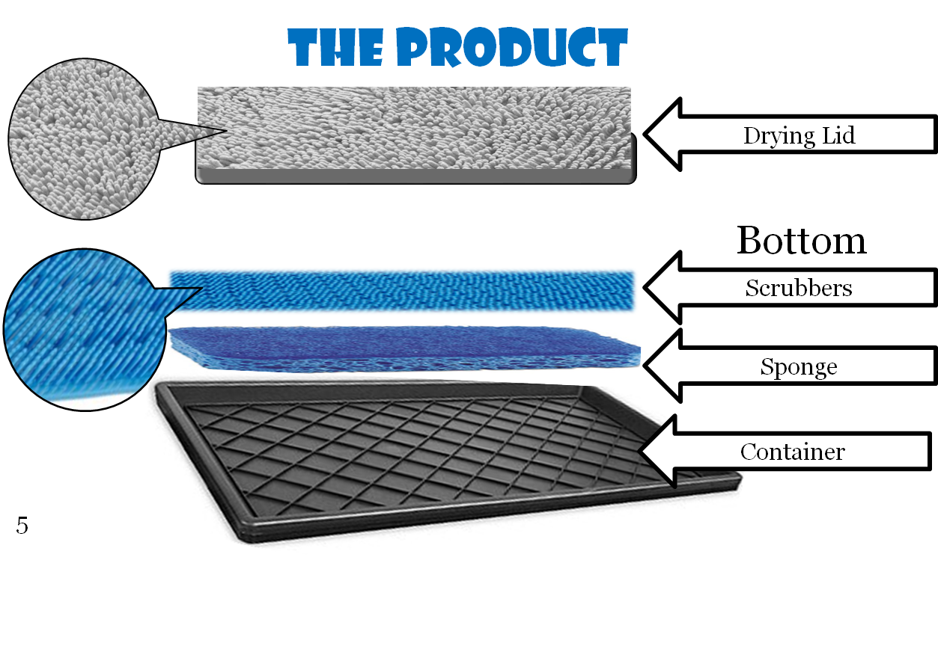

The Pure Paws doormat has a two-part design that allows for both the cleaning and drying of your dog’s paws. The first part of the mat includes rubberized scrubbers, which also serves as a porous layer allowing a reasonable amount of water to secrete at the top. Below this porous layer is a sponge-like material that is soaked in the Pure Paws purifying sanitizer liquid that cleans and moisturizes the paws while being submerged in the rubberized scrubber layer. With each step onto the cleaning mat, the paw presses the rubberized scrubbing surfaces down into the sponge. With the scrubbing surface being porous, it simultaneously scrubs and washes germs and mud away. The first steps taken out of the cleaning mat are on to the product’s lid which doubles as a highly absorbent, chenille microfiber drying mat. Within seconds, the now clean paws, are dry too. There are many elements to our products design that are crucial to the overall appearance, reputation, and usability that it supplies to its customers. Our product is highly environmental friendly and uses the highest quality of recyclable materials. The bottom plastic component of our product is made from 100% of recyclable materials and is a durable plastic that is manufactured to last and withstand a great deal of weight. The rubberized scrubber component of this mat is also made of high quality and eco-friendly material. This antibacterial scrubber mat is designed to remain mold and mildew-free to ensure the safety and cleanliness of dog’s paws and within the home. Pure Paws, LLC created and tested a solution called the Purifying Sanitizer that is proven to be safe to use around any pets or children. This sanitizer is a liquid that rests at the bottom of the Pure Paws mat and secretes through the sponge and rubberized scrubbers as weight is placed on the mat. The purifying sanitizer moisturizes the paw pads and cleanses the paws removing any germs, mud, and other substances. The drying component of this product that doubles as a lid for the Pure Paws doormat is designed to be easily detachable. Simply slide the water tight lid off and place it next to the scrubbing mat. For easy clean up and maintenance, both the rubberized scrubber mat and drying mat are machine washable so that they can be placed in the dishwasher and laundry machines. This feature allows for the product to withstand a greater deal of use and will give the customers the satisfaction of a durable and long-lasting product. Since this product is made from durable and high quality material consumers are willing to spend more money on a product that is good for the environment and safe for their dog to use. 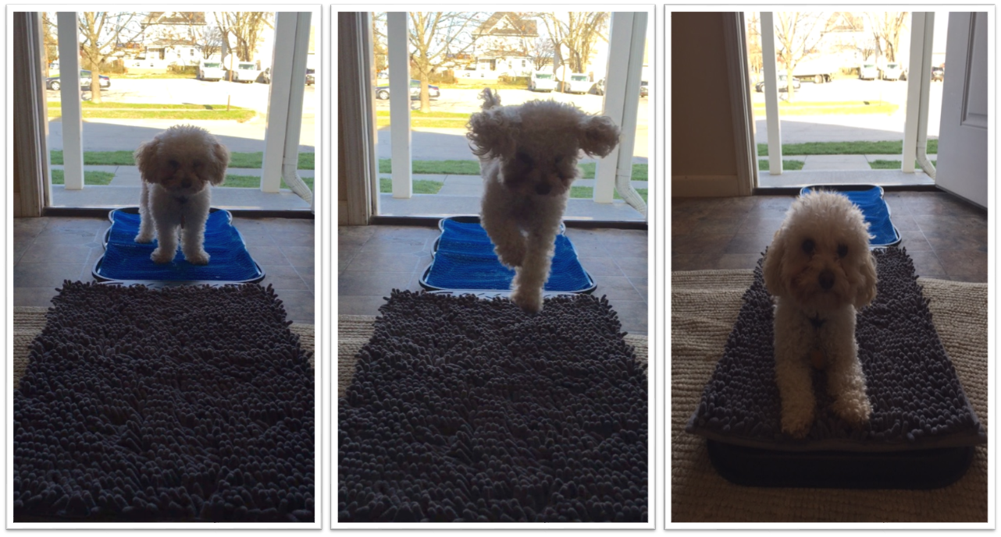
Below is a graph of the breakdown in what it cost Pure Paws to manufacture this product.
Material | Costs
Chenille Microfiber Drying Fabric per yard | $ 1.40
Hard Plastic Lid | $ 1.00
Scrubbers Mat | $ 1.49
Sponge | $ 0.10
Container | $ 1.00
Total Cost to Make Product | $ 4.99

Our product is adaptable to serve a wide market of dog owners. The design is applicable to anyone who has an indoor dog. Every indoor dog tracks in mud, germs, and other unwanted substances into its owner’s home. Many dog owners may not even realize the extent to which this is happening within their household. It is our company’s goal to make our customers more aware of this issue, and provide them with an effective and easy-to-use product to eliminate this problem so that their home is safer for both the dog, and owner.

Industry Description:
Pure Paws, LLC will find its market within the Pet Care Industry for Pet Supplies and Pet Services such as grooming and boarding. This is a constant growing market that will provide Pure Paws with an immense customer base and multiple market segments. According to the APPA, the total U.S. pet industry expenditures increase by billions of dollars each year, more than tripling in size since 1994 when pet industry expenditures were at only seventeen billion dollars. The breakdown for the pet industry sales within the U.S. market is estimated as follows:

Food | $23.04 billion
Vet Care | $15.73 billion
Supplies/OTC Medicine | $13.75 billion
Pet Services: grooming & boarding | $4.84 billion
Live animal purchases | $2.19 billion

Beings that our product would fit into two of the subgroups whose earnings are the highest, our projected success in this industry is promising. Also, according to the 2015-2016 APPA National Pet owners’ survey, 65% of U.S. households own a pet, which equates to 79.7 million homes. In 1988, the first year the survey was conducted, 56% of U.S. households owned a pet. This illustrates the significant incline in the amount of pet owners, and reflects the success of the market in which Pure Paws will be doing business. In fact, a breakdown of pet ownership in the U.S. according to the 2015-2016 APPA National Pet Owners Survey recorded that of all the U.S. households that own a pet, the number of dog owner’s skyrocket above cat, bird, and other small animal pet owners. The pet care industry is very large and has great potential which will offer our company and product endless opportunities. With loyal customers and an ever-growing market base, this industry is both ideal and statistically favorable for this company.

The Market

Market and Target Customer:
According to the American Pet Products Manufacturers Association, Inc. (APPMA), in 2015 $60.59 billion dollars was recorded in industry expenditures. Of that $60.59 billion, $5.24 billion is spent on pet services such as grooming and boarding. The APPMA news release also reported that consumer spending on pet products has more than tripled from $17 billion to a projected $60 billion since 1994 when the APPMA first began tracking pet industry statistics. Target customer is any consumers young or old that owns a dog. The dog owners account for a $60.59 billion industry. We would like to fit into the grooming or house cleaning aspect of this industry. We will mainly focus on selling this product to pet stores where customers shop on a regular basis. We will also sell this product online with our own website as well as other pet store website. It is recorded that for 2015 there are 54.4 million households that own a dog in the United States. The target customer for the Pure Paws doormat is any of those 54.4 million dog owners. The Pure Paws doormat works with any size dog ranging from 5lbs to 200lbs, which helps our product be versatile for any dog. Below is the chart that breaks down the cities dog owner population and market Pure Paws will reach within the first year.

Top Dog Cities Population
# | Cities | Dog Owners | 1/4 % Reach | 3% Reach
1 | San Diego, CA | 262,233 | 656 | 7,867
2 | Philadelphia, PA | 325,271 | 813 | 9,758
3 | Seattle, Washington | 153,000 | 383 | 4,590
4 | Chicago, IL | 1,699,471 | 4,249 | 50,984
5 | St. Lauderdale, FL | 347,877 | 870 | 10,436
6 | Houston, TX | 1,073,185 | 2,683 | 32,196
7 | Las Vegas, NV | 440,603 | 1,102 | 13,218
8 | Los Angeles, CA | 2,989,811 | 7,475 | 89,694
9 | Charlotte, NC | 218,728 | 547 | 6,562
10 | Dallas, TX | 698,671 | 1,747 | 20,960
11 | Denver, CO | 1,793,886 | 4,485 | 53,817
12 | New York City, NY | 1,716,491 | 4,291 | 51,495
13 | Atlanta, GA | 409,132 | 1,023 | 12,274
14 | Miami, FL | 482,984 | 1,207 | 14,490
15 | Detroit, MI | 648,317 | 1,621 | 19,450
 | Total | 13,259,660 | 33,149 | 397,790

Based on our industry research, we think we have opportunities to attract customers from the following market groups:
    - Design professionals
    - Pet care professionals
    - Individual consumers
The first two groups were selected because they offer growth outside of the “usual” pet products consumer; their favorable opinion of the product may help establish product reliability, brand credibility, and influence individual consumer purchases.
The three target market segments selected for this product are design professionals, pet care professionals, and individual consumers. Each segment is outlined and described below.
Design Professionals:
The Pure Paws doormat is a highly innovative and new design that proves interesting to professionals within this industry. The technological design of this product provides a fresh outlook on the traditional way of the cleanliness of dog’s paws and serves its customers through the pleasure of an easy-to-use and hassle-free product that gets the job done without any physical labor. Design professionals would be exceptionally impressed and intrigued with the overall design of this product, resulting in them being a potential target customer.
Pet Care Professionals:
Veterinarians, breeders, kennels and pet day care centers also need access to a customized solution that works best for their clients. Veterinarians recognize the health benefits of clean paws and the effect that it can have on the animal, and household in which it resides. A study found by World Press states that over 200,000 cases of stomach flu each year come from bacterium that was found on dogs paws. The same study proved that dogs can track in bacteria through their paws or mouths. Some of these bacteria found cause MRSA, E Coli, or Salmonella. This is a major health issue that can be avoided by using our Pure Paws Doormat with the Purifying Sanitizer that kills that bacteria. Educating veterinarians on the human risk dog’s bring into the home will help them promote the product to consumers. Veterinarian’s also recognize the benefits that could come from the moisturizing element of our product, eliminating dry, and cracked paw pads that can be a result of cold and wet weather. The pads of a dog’s paw are highly sensitive and can cause major pain and discomfort if they are not treated with care. Pet care professionals are more likely to recognize these types of issues and can offer this product to clients to address those health needs.
Individual Consumers:
The largest number of potential buyers for this product are individual consumers. Industry experts estimate that more than 55% of U.S. households own at least one pet cat or dog; many own multiple pets. The 2000 Census reported a total population of 281,421,960; 55% of that number represents our potential individual consumer market, 154,782,078. The individual consumer is a huge market and is growing as many young people wait longer to get married they adopt dogs for companionship. The other truth that holds for this consumer is that the divorce rate is high and increasing as well, as people get divorced they again look to dogs for companionship. These markets are willing to spend more on their dogs as they have more disposable income.

Competition/ Competitive Advantage:
Listed and described below are the three main competitors that Pure Paws will face on the market.

Paw plunger- This is a smaller and more portable product. However, you have to get down on hands and knees or pick up dog to wash their paws, or if the dog is too heavy to pick up you have to bend over and scrub each paw individually (pictured below). We compete with paw plunger because our product stays on the ground while the dog walks across it. This ease of use system is our main competitive advantage. Our product also moisturizes the dog’s paws to help with dried out paws from walking in the winter months. Paw Plunger may be a more portable way to clean dog’s paws and easier to store but it is threatening to dogs and hard to be trained easily. This product also requires for owners to individually stick each paw and scrub to remove mud. This is unrealistic for consumers to do this every time they walk inside. Paw Plunger also does not sanitize and remove bacteria found on dog’s paws it focuses more on the mud aspect of the business.
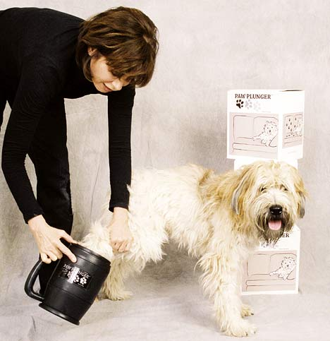

Soggy Doggy Doormat- This doormat is made of microfiber drying material just like our drying lid on our doormat. This will is only a drying mechanism and does no benefit for washing, sanitizing, or moisturizing paws. The only competitive position soggy doggy has is within its design as consumers like the print of an animated paw print. Pure Paws doormat is retailing for around the same price as Soggy Doggy, however Pure Paws mat has so many more benefits. Although this doormat may be stylish it actually does no good in removing mud from dog’s paws easily. The soggy doggy doormat also stains easily which makes it less durable and more likely that consumers will throw it out and have to replace it sooner.
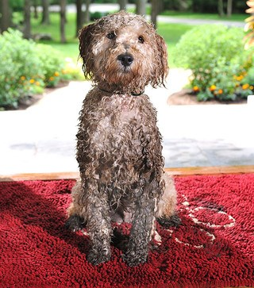

Paw Wipes- This is the cheapest alternative to Pure Paws at around $9.99. Paw wipes are disposable and not good for the environment. One wipe must be disposed of after use and does not assure that the germs are completely off of the dog’s paws or that the chemicals in these wipes are safe for the dogs to ingest. These Paw Wipes are also not moisturizing or easy to use on all sizes of dogs. Another disadvantage to Paw Wipes are that many dogs do not like their paws being touched. This is one of the biggest problems reported when dog’s go to check up’s. Having to wipe the dog’s paws individually will take more time and many dogs fight their paws being touched in the first place.
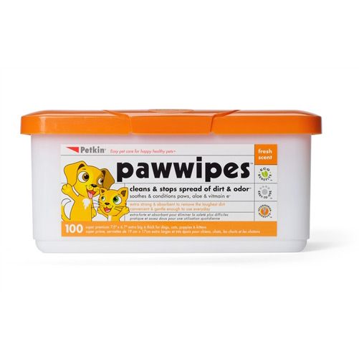
Below is a chart that easily displays the competitive position of Pure Paws and its main competitors. This judges each brand by sanitization, moisturizing, ease of use, non-threatening level, durability, stop the prints, and last it ranks the prices. As displayed below Pure Paws and Soggy doggy are in the same pricing bracket while Paw Plunger is ½ the price but way more than triple the work. Paw Wipes are the cheapest alternative but are not necessarily safe for dogs to ingest the solution or proven to kill germs. Paw wipes are also not durable or eco-friendly.

Competitive Position
 | Pure Paws | Paw Plunger | Soggy Doggy | Paw Wipes
Sanitizes | Yes | No | No | Yes
Moisturize | Yes | No | No | No
Ease of use | Yes | Yes | Yes | No
Non-Threatening | Yes | No | Yes | Yes
Durability | Yes | Yes | Yes | No
Stop Paw Prints & Dry paws | Yes | No | No | No
Price | $39.99 | $21.99 | $39.99 | $9.99
Marketing strategy:
Overall Strategy- We will focus on advertising the product more for sanitizing in big cities and large populations. We will change our marketing strategy within smaller towns and in the Midwest to focus more on the benefits of getting mud off the dog’s paws. The moisturizing element to our product will be advertised to both populations as well as the benefits of the products durability and eco-friendly qualities. Pure Paws will share viral videos on social media creating buzz and spreading the word on our product, as well as create a social media page to earn loyal customers and promote the product. Pure Paws will also be going to trade shows to show the product to consumers. We will send out free trials to celebrities to try to get endorsements from them. We will go to parks and educate consumers about the health risks dog’s paws are bringing into their homes. Pure Paws will also pay money to big box stores to get advertisement time on their commercials. Pure Paws will be paying google a $.10 fee for key work metrics that when searched our website will come up in their search. The keywords include; muddy paws, germs, dirty floors, puppy, muddy, door mat, sanitizes, moisturizes dogs paws, super absorbent, scrub paws, bacteria on dog’s. Our Regional Management team will split up into three regions, (east, mid-west, and west), and go to the top fifteen cities to get into local stores pet and retail stores.
Sales Plan- Our Company’s goal is to inform consumers of the uses and benefits of the product within the next year. We will do this by marketing to consumers through television advertisements and social media. Pure Paws’ plan is to have the product in 2,400 pet stores in one year. We will do this by creating relationships with management across the country to get our product into their stores. Our sales goal is to sell 33,149 units within next year. We will strive to reach our sales goal by having a successful marketing and management team to get the product idea out to consumers and into stores. We plan on reaching out to 2,400 stores, including Target, Walmart, Petco and Pet Smart. Pure Paws will plan on selling the product to ¼ of each of these stores nationwide. Below is a graph that depicts the breakdown of each of these stores.

 | Stores Nationwide | Stores we will sell to
Target | 1805 | 451.25
Petco | 1400 | 350
Pet smart | 1400 | 350
Walmart | 5000 | 1250
Total | 9605 | 2401.25

Selling to these stores will provide our company with an adequate amount of profit and sales within the first year to keep a positive cash flow and create an efficient net income for our company. Outside of these stores, we will be reaching out to local city stores and gaining inventory within individual stores. Pure Paws management team will also be attending trade shows and sample booths at local parts to educate the consumer about the bacteria found on dog’s paws and the negative effects it can have on the dog, owner, and household.

Competitive Analysis
    - Strengths- This product is very easy to use and eye pleasing. The doormat is compact. The product is non-threatening to dogs and it moisturizes and sanitizes a dog’s paw pads. Portable and durable so it is able to be walked on.
    - Weakness- The size of the doormat makes it unable to store directly in front of the doorway like a normal doormat. Product must be portable and storable since it cannot remain by the door. Not usable for humans.
    - Opportunities- The Pure Paws doormat is the first product on the market with both a sanitizing and moisturizing component in the form of a doormat. With a unique and innovative design, this product will stand out and make a big impression compared to its competitors.
    - Threats- There are other products on the market that assist with messy dog paws. Also the price of our product compared to the ones of our competitors can be seen as a threat because our product is not cheaper than some. The product requires setup and up-keep.
    - Current competitors- Paw plungers, soggy doggy, paw wipes

Research and Development:
    - Social media networks to listen to customer needs
    - Subscribing to pet magazines to stay current with competitors and customer’s needs.
    - Use technology to cheaply manufacture a quality product
    - Creation of solution formula, research how to create a product that sanitizes and moisturizes.
    - Future products would include other items for dogs and keeping them clean and happy.
Exit Strategies:
The primary exit strategy is to sell Pure Paws LLC within 5 years of the release of the product after it makes its appearance into desired retail stores. At that point Pure Paws will have gained a reasonable profit margin. Investors will collect their initial investment plus their share of the profit after the sale of Pure Paws is finalized.

The second exit strategy is to sublicense the product if Pure Paws is not sold five years following the release of our product. Potential sublicensing partners will likely be the same companies that were approached regarding potential acquisition. The revenue stream generated by royalties will be used to fund tasks associated with Pure Paws. Pure Paws will again approach companies regarding potential acquisition after the Pure Paws Doormat has been sublicensed for a year.

If the team fails to sell Pure Paws or sublicense the doormat design, then investment(s) can be claimed as a tax deductible loss.

The Organization

Legal and Organization Structures:
Pure Paws is a limited liability corporation with four co-owners that serve as department managers. Pure Paws is filed with incorporation papers through Missouri. Three department managers will be sectioned into regions where they will travel and build relationships with stores to get inventory turnover. Kailey will be in charge of the East Coast region, Breanna will be in charge of the Midwest, and Heath will work on the West coast. Communication between the three regional department heads is key to keep up with changing consumer’s needs and trends in the market. Andrea will also be in charge of the Human Resource Department and headquarter out of Maryville.

Name Address SSN Ownership
Kailey Elstrum 76 Appletree Ln, NY 622-09-9371 25%
Breanna Ripley 329 Cranberry St, MO 734-55-3442 25%
Heath Loeffelbein 284 Hollow Ave, CA 833-22-7897 25%
Andrea Brown 091 Carson Cir, MO 089-43-9372 25%

The structure of Pure Paws will consist of only the four co-owners for the first three years. Pure Paws will not have any external hiring strategy or extra payroll expenses unaccounted for. Pure Paws will have a utility patent on the doormat as well as intellectual property protected by patents.

Variable Costs: Commission on sales, COGS,
Fixed Costs: Rent, Telephone, Travel, Insurance

Web Information: <www.PurePawsLLC.weebly.com>

Pure Paws will have liability insurance which will protect the business from a variety of claims including property damage, bodily injury, personal injury, and others that can arise from the business operations. Liability insurance will also cover things such as advertising injury. Having liability is important because the variety of offenses that can occur. Pure Paws will also obtain a utility patent. This patent will be granted to Pure Paws due to the invention of a new a useful process such as the doormat. This will protect Pure Paw’s invention for twenty years. These exclusive rights will prevent other people from using, making or selling the doormat which will easily reduce competition. Obtaining a patent will also allow Pure Paws to be perceived as a demonstration of a high level of expertise, specialization and technology capacity. Pure Paws will file the patent early in order to be first to the market. Pure Paws will seek a patent with an opinion of an attorney. It is important to receive an opinion due to making the right business decision and it will provide coverage just in case Pure Paws ever faces litigation. Getting a competent opinion from an attorney can be critical in making the right business decisions for Pure Paws. This will give a green light to take the doormat to market by addressing any legal risks that could be faced.

Key Personnel:
Pure Paws does not need a full-time manager. Instead, Pure Paws has a general oversight that is needed to ensure that progress remains on schedule. One of management’s primary concerns will be securing relationships with Target, Walmart, Petco and Pet Smart. These responsibilities will be managed by Health L., Kailey E., Breanna R., and Andrea B.

Heath L., Ph.D.
Heath L. has thirty years of experience in veterinary medicine research. Heath L. also has fifteen years of experience in marketing research. Heath attended Iowa State University for eight years where he graduated with his doctorate in Veterinary Medicine. He spent time after this working in a lab diagnosing, treating, and controlling diseases and injuries among animals. Heath L. has been responsible for creating our formula that sanitizes dog’s paws. Heath will also be responsible for making key decisions as to which companies to create contracts.

Kailey E., Ph.D.
Kailey E. is an entrepreneur and has started and sold five of her own businesses throughout her life. Kailey E. also has 8 years of experience with marketing for major corporations. Kailey studied marketing and business management at Northwest Missouri State University. Kailey continued her education in marketing research obtaining her doctorate degree. Due to all of her hard work, Kailey has been in charge of Ralph Lauren’s shop in Herald Square which is a $5million dollar business. This experience has given her great knowledge in managing a team and managing financial planning. Kailey also grew up around entrepreneurs as 3 of her uncles all started their own business and have given Kailey great advice for this plan. Kailey will be responsible for managing Heath, Breanna and Andrea as well as managing the financial planning. Kailey will be in charge of tax planning, investment planning, and protection planning as well.

Breanna R., Ph.D.
Breanna R. has been a certified public accountant for over fifteen years. Breanna attended Northwest Missouri State University where she studied accounting for four years. Breanna went on to get her doctorate degree in public accounting. As the chief executive officer, Breanna has maintained and audited financial company records, and has offered our firm fiscally advantageous methods to save money. Breanna is responsible for many things with Pure Paws. Breanna will be responsible for reporting financial information to management, create and analyze budgets, advice management on tax ramification of business decisions, oversee accounts payable and receivable as well as participate in strategic planning, fraud prevention and budget development.

Andrea B., Ph.D.
Andrea B. is the CMO for a marketing research firm and has twenty years of experience. Andrea attended Northwest Missouri State University where she studied both marketing and business management. Andrea went on and studied four more years obtaining a doctorate degree in marketing research. As the CMO, Andrea has been responsible for overseeing the planning, development, execution for the firm’s marketing and advertising initiatives. The primary responsibility for Andrea is to generate revenue by increasing sales through successful marketing for Pure Paws, using marketing research, pricing, product, marketing, marketing communication, advertising and public relations. Andrea always has other roles that have been expanded. Andrea is also responsible for helping with Pure Paw’s development, product development and customer service.

Board of Directors:
Pure paws is a privately held company that will not have a board of directors. If the founders decide to go public with the organization then we will elect a board of directors to talk directly to shareholders. Until then Kailey Elfstrum will talk to the bank or investor where Pure Paws receives its loan from.

Related Service Providers:
Pure Paws has developed strong partnerships that will help propel the product to each milestone. Listed below are brief descriptions of Pure Paw’s partners:
    - Pet smart is an American retail chain that operates in the United States as well as Canada and Puerto Rico. They are engaged in the sale of specialty in pet supplies as well as other services. These other services include: dog training, cat and dog boarding facilities, and grooming. Pet smart also offers a variety of animals for sale and adoption.

    - Petco is a privately owned retailer that operates in the United States with their corporate offices located in San Diego and San Antonio. Petco sells pets as well as pet products and services. Petco also is engaged in other services which include grooming and dog training. Petco operates in more than 1300 locations.

    - Alston + Bird LLP is a leading national and international law firm. Alston + Bird LLP develops, assembles and nurtures the strongest array of legal talent and expertise that is necessary to meet all of their clients’ needs.

    - Walmart is the largest multinational retail corporation that operates a chain of hypermarkets, discount department stores, and grocery stores. Walmart’s headquartered in Bentonville, Arkansas. Walmart supplies a variety of animal supplies. For dogs specifically they provide: carriers and kennels, collars and leashes, treats and chew toys, gates, doors, training gear and dog beds. They also provide flea and tick treatment, a variety of dog food, products for cleaning up, healthcare products as well as natural and organic foods.

    - Target is the second largest discount retailer in the United States. Target is engaged in the sales of different animal supplies. For dogs specifically they sell apparel, beds, bowls and dishes, collars, leashes, crates and kennels. Target also sells food, treats, grooming supplies, and health and safety products.

Location:
Pure Paws’ office headquarters is located in Maryville, Missouri out of the Center of Innovation and Entrepreneurship building on the Northwest Missouri State University campus. This is located at 1402 N College Dr, Maryville, MO 64468. Our Rent for the first 6 months will be free as we are estimating to win the first place prize at the new venture pitch competition. After 6 months our rent will cost $568 monthly, totaling $3,410 in the first year. The office space which offers state of the art research facilities, a commercial analytical lab, and tailored support for business acceleration. Pure Paws management team feels confident that this is the perfect place for our business. Our product will be sold nationwide in various animal supply chains such as Petco and Pet smart. We currently rent the office property and utilize it to host meetings, seminars, and other promotional activities regarding our product. This facility strives to assist our employees to meeting the strategic and sales goals of our company by providing all of the essential tools for marketing, online sales, and management. While some of the management team is traveling to our top 15 cities to promote the product there will be weekly video conference calls headquartered from our office in the CIE building. Within our start up fees each member of our management team will receive a laptop so we can video conference weekly to keep up with consumers trends and wants in the market with stores. We will also be utilizing the CIE building as office space and as our headquarters to manage our online sales and other administrative duties. We will be using a website and buying the domain for www.PurePawsLLC.com. However, our pre-business domain is under www.PurePawsLLC.weebly.com.

The Financials
Below is a graph we pulled together from our Income Statement, Balance Sheet and Cash Flow Statement. This shows our Pre-business finances as well as our company's three year plan. There will be some very high expenses in our start up as we need to build relationships with stores across the country and travel to make sure our product is displayed in store across the country. We will be paying for end caps and displays in each of the stores.

Pro Forma Financials
 | Pre-Business | 2017 | 2018 | 2019
Sales | - | $ 497,235 | $ 646,406 | $ 969,608
Units Sold |  | 33,149 | 43,094 | 64,641
COGS | $ 248,400 | $ 165,745 | $ 198,894 | $ 298,341
Expenses | $ 30,000 | $ 195,585 | $ 194,248 | $ 201,002
Net Income | - | $ 137,905 | $ 253,263 | $ 470,266
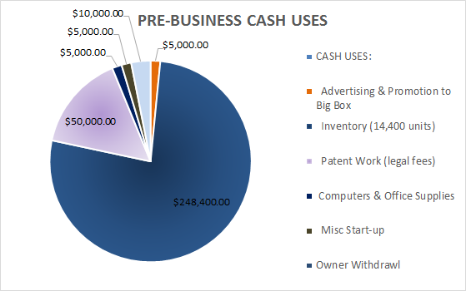
Pure Paws doormat will manufacture the doormat in large units. Our first inventory order in pre-business will be for 14,400 units. This will cost our company 248,400 which is a major expense but we believe it is a necessity to stock our pipeline and keep inventory in all our store in the top 15 cities. This will help boost our sales within the first year since our retailers will already have the product out for consumers. Pure Paws doormat will be produced for $5 a unit. This is calculated as the Chenille Microfiber drying lid costs $1.40 to make. The Hard plastic lid costs $1.00 to make as well as the bottom container costs $1.00. The sponge for the dimensions of the mat costs us $.10 to make per unit. The scrubber mat costs $1.49 to produce and manufacture. Together the product costs 4.99 to make and produce. Below is a graph of pre-business cash expenses. The biggest expenses in pre-business is building inventory.

Below is a chart that explains percent of sales within the company. This is at the end of year 1 that the percent of sales for COGS is 33.33%. This is equal to $165,745 in producing the product. Net Income for year one is equal to 27.8% of sales, which is $138,237. Expenses for year 1 are 33.33% of sales. Out of the 38.87% of expenses 24.13% comes from traveling to educate and promote the market. Pure Paws believes this is an essential part for the company to succeed and do so well within the first year as we need to get our name out there. Having a BEP that shows positive cash flows is an example of how well the company will do and what a great investment opportunity Pure Paws is.
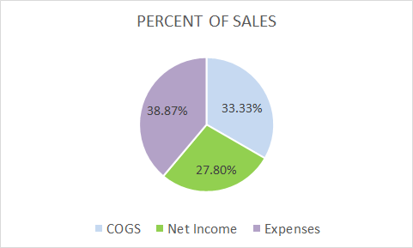

Pure Paws has a great trend for product revenue. Within the first 3 years sales are expected to grow 2% after the first year and 5% on top of that the next year. By year 3 Pure Paws is expected to have sales of $969,608 and a net income of $470,511. Below is a more detailed graph of projected product revenue of sales and net income in US dollars. Overall, as you can see Pure Paws has steady growth and a huge upside potential within the market.
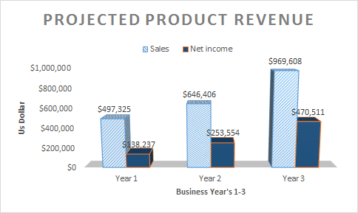
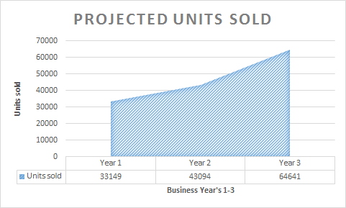
The company will be wholesaling this for $15.00 to retailers. This is a 50% markup rate and will help us produce a great net income on the product. We suggest retailers to sell the doormat for $39.99 which will be a 50% markup rate for retailers as well. We believe this is a realistic price scale and know this will lead our company to success with our profit margins. We projected units sold by taking a ¼ of a percent of the pet industry in the top 15 cities in the first year. Within the first three years Pure Paws is expected to have a positive trend in units sold. Below is a chart displaying the projected units sold within the first three years.

Our Management team will be traveling to the top 15 cities in the United States for dog owner population. This includes the cities; San Diego, Philadelphia, Seattle, Chicago, St. Lauderdale, Houston, Las Vegas, Los Angeles, Charlotte, Dallas, Denver, New York City, Atlanta, Miami, and Detroit. Overall the population totals of these top 15 cities total to 13,259,660 dog owners. We plan on reaching ¼ of a percent of these dog owners within the first year. This will equal 4,485 people within the top cities. This is a very conservative estimate and we did not include potential online sales.

Cash Flows:
Overall financially Pure Paws has a very stable future when calculated in a conservative way. Therefore the possibilities have huge potential in the pet industry if it grows quicker than projected in our conservative estimate. Pure Paws is excited to see what the future hold for the company financially.

The Appendices

Customer Testimonials:
Quintin, from Wisconsin said: "My dog Nimba always tracks mud into the house from our yard. Pure Paws doormat has changed that. I no longer have to bend down to wipe each of her paws off individually or try to stop her from running inside and getting mud all in the house. "

Lisa, from Las Vegas said: “My family has two dogs who we all love, but the worst part about taking care of them is the mess they make when coming back into the house. Pure Paws Doormat has helped keep my house cleaner than ever without any of the work. Thank you Pure Paws! "

Kendall, from New York said: "I love running with my dog every morning. However, I hate thinking about all the germs from the city streets all over his paws. Pure Paws Doormat was such a convenient way to keep my apartment clean and get the germs off of my dog's paws before he jumps on the couch with me to watch the morning news."

Sources:
http://www.marketingmypetbusiness.com/2014/02/the-top-pet-industry-trends-for-2014.html
https://www.franchisehelp.com/industry-reports/pet-care-industry-report/
http://www.americanpetproducts.org/press_industrytrends.asp

Financials:
Attached separately are our full Pro Forma Financials.

